**Patient Health Care Monitoring System in IOT**

**INTRODUCTION**

Doctor's facilities continuously require exceptional administration. The database of every last bit patients ought be helpful sufficient. Be that as also, there ought to a chance to be information avoidance. Likewise the tolerant information ought further bolstering be kept private in the event. Social insurance may be the majority critical concern from claiming numerous nations in the universe. Enhancing those exists of patients particularly in the weaker parts of the particular social order which incorporate those elderly, physically also rationally handicapped and additionally the chronically sick patients may be the main consideration will make progressed. On existing system, those information is recorded in the manifestation from claiming paperwork or looking into general stockpiling server. However by and large that information will be approachable on every last one of staff Furthermore doctors. Subsequently we need aid proposing another route the place tolerant

**Problem Statement**

In today’s social Health Insurance structure where patients stay at home after Operations they are monitored by a medical caretaker or a family member. Many people nowadays who work full time are facing a problem of monitoring their loved ones especially old age patients . So to overcome this problem my project will take care of patient’s health by monitoring heartbeat and body temperature. We are implementing this patient health monitoring system using IoT. This Uses sensor technology with micro-controller and wifi module to help the user monitor there loved ones .

**Objectives**

Aim is to make a working model which can measure the heartbeat and temperature of patients when doctors are not around them. Nowadays Health-care Environment has developed science and knowledge based on Wireless-Sensing node Technology oriented. Patients are facing a problematic situation of unforeseen demise due to the specific reason of heart problems and attack which is because of nonexistence of good medical maintenance to patients at the needed time. This is for specially monitoring the old age patients and informing doctors and loved ones. So we are proposing a innovative project to dodge such sudden death rates by using Patient Health Monitoring that uses sensor technology and uses internet to communicate to the loved ones in case of problems . This system uses Temperature and heartbeat sensor for tracking patients health. Both the sensors are connected to the Arduino-uno . To track the patient health micro-controller is in turn interfaced to a LcD display and wi-fi connection to send the data to the web-server(wireless sensing node). In case of any abrupt changes in patient heart-rate or body temperature alert is sent about the patient using IoT. This system also shows patients temperature and heartbeat tracked live data with timestamps over the Internetwork. Thus Patient health monitoring system based on IoT uses internet to effectively monitor patient health and helps the user monitoring their loved ones and it saves lives.

**Methodologies**

The system consists of six major embedded electronics. 1. ECG Sensor 2. Heart Beat Sensor 3. IR Sensor 4. GSM Module 5. Arduino UNO. 6. LCD Display. For power on, 12 volt adapter is using with Arduino and 5 volt adapter attached with GSM module externally. Patient will touch the heart beat sensor, and then the IR sensor’s ray will count the beat from blood flow. After counting beat from blood flow we will push the button H-Beat and wait for 20 seconds. The result will upload and the heart beat value will show in LCD display. Similarly using UH push button the receiver will get the value in mobile message, web page and android application. For implement the function of ECG sensor, the sensor will be attached with patient’s chest and push the button ‘ECG’. In the meanwhile, it will generate the ECG curve. After that, the curve will upload on website.

**Expected Result**

After connecting and programming all the components with each other, we have performed the experiment. According to the proposed system, we have designed prototype Iot based Patient monitoring System. Arduino, GSM module and all the sensors are connected with lots of wires.

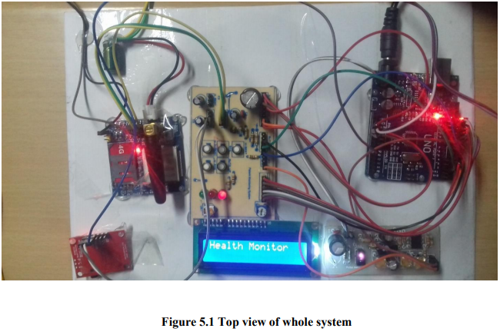

To verify whether the heartbeat sensor is working or not, we compare the heartbeat result with an automatic blood pressure machine’s heartbeat output. To proceed with this thought, we have checked the data which is taken from 5 various people having specific age limit. The data is given below with specific date and time.

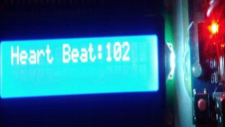

**References**

[1] Iman Azimi, Arman Anzanpour, Amir M. Rahmani, Pasi Liljeberg, Tapio Salakoski, “Medical Warning System Based on Internet of Things Using Fog Computing”.

[2] Vivek Pardeshi, Saurabh Sagar, Swapnil Murmurwar, Pankaj Hage, “Health Monitoring Systems using IoT and Raspberry Pi – A Review”.

[3] S.Lavanya, G.Lavanya, J.Divyabharathi, “REMOTE PRESCRIPTION AND IHOME HEALTHCARE BASED ON IoT”.

[4] R.N. Kirtana, Y.V. Lokeswari, “An IoT Based Remote HRV Monitoring System For Hypertensive Patients”.

[5] Ruhani Ab. Rahman, Nur Shima Abdul Aziz, Murizah Kassim, Mat Ikram Yusof, “IoTbased Personal Health Care Monitoring Device for Diabetic Patients”.

Submitted On:

Student 1 Name and Reg No :

Student 2 Name and Reg No :

Project Batch No ( student may fill once it is assigned):

Guide Name and Employee ID:

Guide Signature with date:

Guide Comments:

MDD Faculty Name and Signature with date:

MDD Faculty Comments: